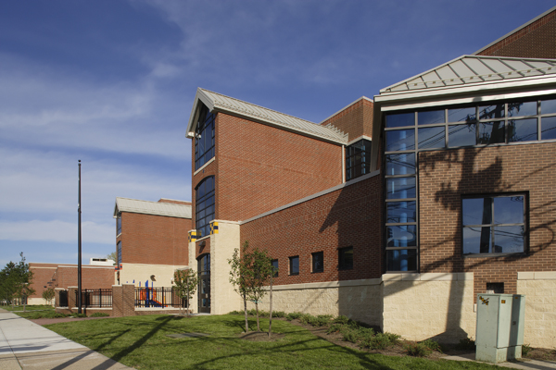

MINIMUM CAPACITY :-

The Minumum intake capacity

of students is between 300-620

children

LIBRARY :-

The Libarary is Available.

CANTEEN:-

The Canteen Facility is Available.

BOARDING :-

No availablility of boarding.

SPORTS :-

There are different categories

sports available.

Girls Volleyball

Boys Volleyball

Football

|  |  |  |
| --- | --- | --- |
| COLUMBUS ELEMENTARY SCHOOL  UTICA - SCHOOL |  |  |
|  |  |  |
| School Detail :- Columbus School Vision: Children are our future. We are dedicated to their success. Columbus School Mission: We, the Christopher Columbus Elementary Students, will graduate from the Utica City School District college and career ready. Working Together Today for our Future Tomorrow. Working Together Today for our Future Tomorrow. Working Together Today for our Future Tomorrow. |  |